

American International University-Bangladesh (AIUB)
Department of Computer Science
Faculty of Science & Technology (FST)
Research Methodology
Assignment
Faculty: Dr. M. Mahmudul Hasan
Submitted By
Md Tanvir Arabi

Semester: Summer_2023-2024 FINAL TERM |  |  |  | Section: M |  |  | Group No:03
SL | SN | Student Name | Student ID | Total Marks: 50
 |  |  |  | CO1  (9) | CO2  (9) | CO3  (9) | CO4  (9) | CO5  (9) | Viva  (5)
A | 25 | Md Tanvir Arabi | 22-47857-2
B | 11 | Lamia Tahsin | 22-46345-1
C | 15 | Prithwib Sparshaw | 22-46724-1
D | 14 | Golam Rabbani | 22-46560-1

Submission Date:17.06.2025

Collaboration with Local Law Enforcement: Ensuring Women's Safety in Bangladesh
Md Tanvir Arabi, Lamia Tahsin, Prithwib Sparshaw, Golam Rabbani
Department of Computer Science
American International University, Bangladesh
22-47857-2,22-46345-1,22-46724-1, 22-46560-1@student.aiub.edu

ABSTRACT: This study investigates the potential for local law enforcement, technology, and communities to enhance the protection of women through collaboration. The study shows that there are problems with police-community cooperation and public trust in law enforcement. It does this by using surveys, interviews, and a prototype system like the QRA app. The main results reveal that Information and Communication Technology (35%) and Police Leadership (27.5%) are very important for working together well. Also, many think that local police applications (36.8%) and police units (34.2%) are the best ways to be secure. The study talks about the Integrated Community Safety Network (ICSN), which encourages community involvement, accountability, and easier reporting using technology. This long-term and proactive plan is in line with both national development plans and the Sustainable Development Goals. Its goal is to make the world a safer place for women and encourage them to take part in public life more.
KEYWORDS: Women’s Safety, Local Enforcement and Community Cooperation, Community Help for Safety, Technology for Reporting Crime, Local People’s Involvement, Violence Prevention Safety Policies, Social and Cultural Issues, Long-Term Safety Plans.
INTRODUCTION: During the mass uprising, many female friends and family members shared how they felt unsafe while going out after sundown or how they completely avoided it.The situation was particularly dire during the few days when law and order in Bangladesh completely collapsed. Dhaka University student Jannatul Promi, 23, said that the rising incidences of harassment had left young women feeling unsafe. We are going through a crisis,” she said. “The other day, I was waiting for the metro when a man approached me and asked if I should be outside without a veil. As soon as I responded, more people joined the man in opposing me. [DAWN-AFP in Dhaka on March 5,2025]. Fellow student Nishat Tanjim Nera, aged 24, said the authorities had failed in their duty. Harassment incidents are happening repeatedly, but there is no redress from the government, she said. [DAWN-AFP in Dhaka on March 9,2025]. Another victim, Shaila Bithi, a prominent mountaineer, was physically attacked in broad daylight while crossing a footbridge in Dhanmondi. Her case, like many others, reflects a larger trend of harassment in public spaces, further exacerbated by the thin police presence. Activists and rights groups have raised concerns that a lack of visible law enforcement is emboldening harassers, who feel they can get away with their actions. [UNB-21 September 2024, The Business Standard]. In 2009, the Bangladesh High Court declared a historical judgment to address sexual harassment at the workplace and educational institutions in both public and private sectors. The judgment highlights actions including the establishment of an anti-harassment committee. It also calls for employers and authorities in charge of educational institutions to take preventive measures by raising awareness about sexual harassment. [Tasneem Tayeb, March 7,2020, The Daily Star]. According to a study conducted by Karmojibi Nari and CARE Bangladesh, about 12.7 percent of women employees face sexual harassment in the workplace. We live in a society where a significant proportion of women face gender-based violence regardless of their profession (for example, police officers) or where they live (urban or rural areas). We firmly believe that it is imperative for civil society to unite in discussing workplace harassment and devising strategies to eradicate this issue. [Humaira Aziz, Director, Women and Girls' Empowerment Program, CARE Bangladesh - The Daily Star]. According to the latest Women, Business and the Law report, although 151 countries now have laws against sexual harassment in workplaces, fewer have regulations that address sexual harassment in educational institutions (75), in public spaces (39), and online (75). In 98 countries, sexual harassment legislation does not include criminal penalties or civil remedies. In 2021, the Bangladesh Women’s Lawyers’ Association conducted an analysis that revealed 84 percent of women experience sexual harassment in workplaces and public spaces, including schools, streets, public transportation, and even at home. Many more women face sexual harassment online [The Daily Star]. This research looks at how working together with local law enforcement and the community can help keep women safe in Bangladesh. Unlike other studies that mainly focus on laws or cultural issues, this study highlights how local people and police can partner directly. It explores new ideas like community policing, special help desks for women, and using technology to report problems. The paper gives a new way of thinking about how to prevent crime and build trust in local areas. Law enforcement needs to be stronger and faster. This research adheres to established ethical principles by emphasizing women's safety, upholding human rights, and ensuring transparency throughout their processes. It evaluates the use of technological solutions such as mobile safety applications and digital reporting platforms in a manner that safeguards user privacy and promotes ethical usage. This study is motivated by the ongoing problems women face with safety in Bangladesh, worsened by a lack of strong teamwork between local people and the police. This study is keen to explore how working together, with the help of technology and community support, can make women feel safer. The main goals are to:
- Find out what stops local police and communities from working well together to protect women.
- Learn about beneficial community policing ideas that could work in Bangladesh.
- Understand how people in the community see the police and whether they trust them.
- Study how tools like mobile apps and helplines help report and stop violence against women.
- Look at social, cultural, and economic issues that affect how well these efforts work.
- Find ways to keep these safety efforts effective over the long term through local partnerships.
Q1: Who plays the most critical role in ensuring effective collaboration between local law enforcement and the community for women’s safety?
Q2: Who do you trust most to protect women from violence and harassment in your community?
This research directly addresses the urgent and ongoing issue of women’s safety in Bangladesh, particularly in public spaces. By focusing on collaborative efforts between local law enforcement and communities, the study offers practical, people-centered solutions to a problem that affects half the population and indirectly impacts everyone in society. The research contributes to:
National Development: Safer public spaces empower women to fully participate in the workforce, education, and civic life, thereby contributing to national the key goals of Bangladesh’s development agenda and the Sustainable Development Goals (SDGs) include productivity, economic growth, and gender equality.
Individual Empowerment: Women and girls will benefit directly from safer environments, quicker reporting mechanisms, and greater social support. The use of technology ensures that even those with limited access to police stations can report abuse or harassment.
Target Audience and Beneficiaries
Government and Policy Makers: They can use this research to implement localized, effective safety measures and training modules for police on gender-sensitive practices.
Law Enforcement Agencies: Police departments can benefit from community feedback and technology-driven reporting systems that help them respond more quickly and efficiently.
Community Leaders and Civil Society: NGOs, local leaders, and women's rights organizations can use the findings to build grassroots programs that increase trust and participation in local safety initiatives.
RESEARCH METHODOLOGY: This study adopts a mixed-methods research approach to explore the collaborative role of local law enforcement and community members in enhancing women’s safety in Bangladesh. The methodology integrates both quantitative and qualitative methods to ensure a comprehensive understanding of the issues surrounding gender-based violence and public safety. The research process includes system analysis, prototype development, field surveys, structured interviews, and observational assessments.
System Design and Technical Framework:
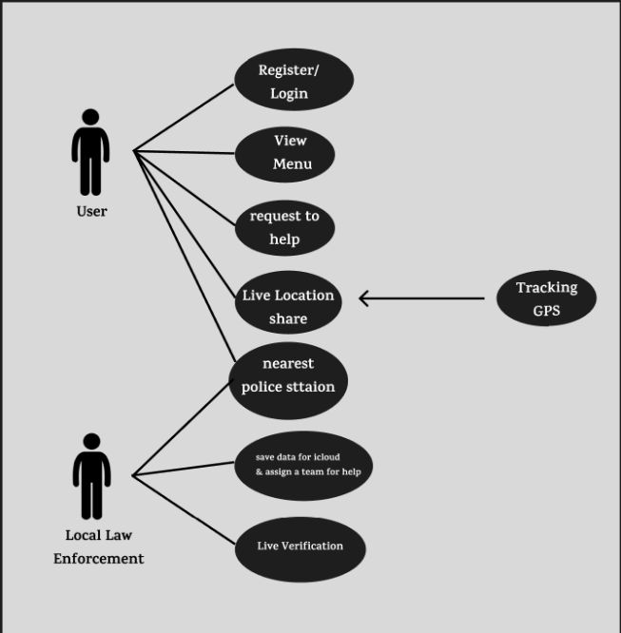 | 
Figure 1: UC (User & Local Law Enforcement) Figure 2: QRA Live GPS track and share overview
The study adopts a mixed-methods approach that includes system analysis, prototype development, field surveys, interviews, and observational assessments. The QRA system, as depicted in the conceptual framework, is designed to enable users to register, log in, view personal contact information, locate nearby police stations, track real-time locations, and send emergency alerts to local law enforcement. Additionally, the system supports volunteer logins, cloud-based data updates, and shows live GPS navigation for safe routing and quickest access to help. This technical infrastructure is complemented by a real-time location mapping system, as visualized through GPS navigation imagery, which represents how users can see safe paths and police stations near their location during emergencies. To understand the needs, experiences, and expectations of potential users, primary data will be collected through structured interviews and open-ended surveys involving women from diverse backgrounds, as well as law enforcement officials and potential system developers. This qualitative data will be essential in identifying the practical challenges and emotional concerns surrounding personal safety. At the same time, system usability tests and field simulations will be conducted to observe how users interact with key features such as emergency notification, location sharing, and police response. Secondary data will be gathered from new reports, published articles [ref-1,2,3,4] and government safety initiatives to provide contextual insights into the safety landscape in Bangladesh. These sources will aid in evaluating how a digital intervention like QRA could bridge gaps between victims and responders. For data analysis, quantitative findings from surveys and system logs will be analyzed using statistical tools to determine correlations between system features and perceived safety. Meanwhile, thematic analysis will be used to interpret qualitative inputs from user interviews and focus groups, helping to uncover deeper insights into the cultural and psychological barriers that women face when seeking help. The development and deployment of the QRA prototype will rely on cloud integration, GPS APIs, and mobile user interface technologies to simulate real-world conditions. Ethical guidelines will be strictly followed, ensuring participant consent, privacy protection, and collaboration with local authorities to maintain integrity and safety throughout the research. In essence, this research methodology combines the technological feasibility of a real-time emergency response app with the human-centered approach required to address women’s safety, making it both practical and socially responsive.
RESULTS & ANALYSIS:
The following information has been extracted from the Survey based on the collected data. This information will analyze the research questions:
Q1.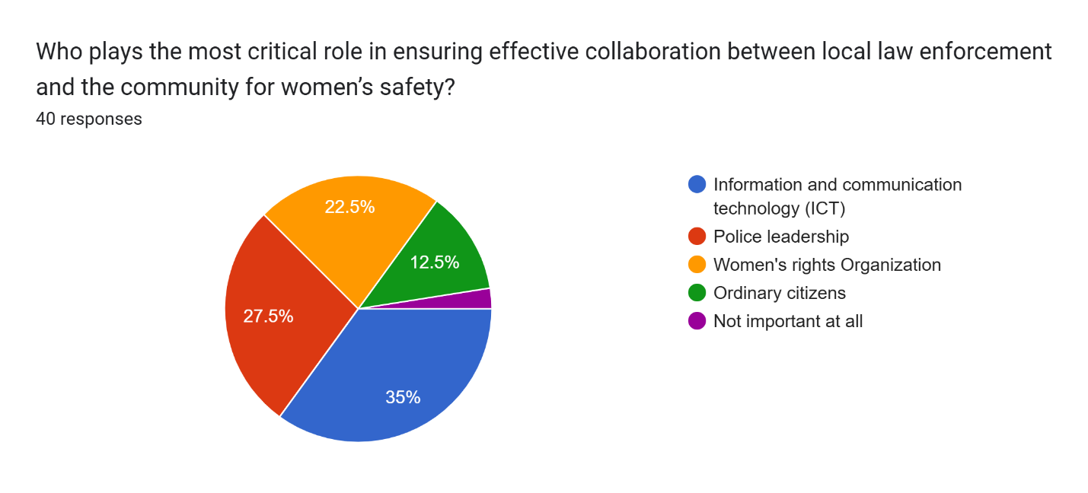
Q2. 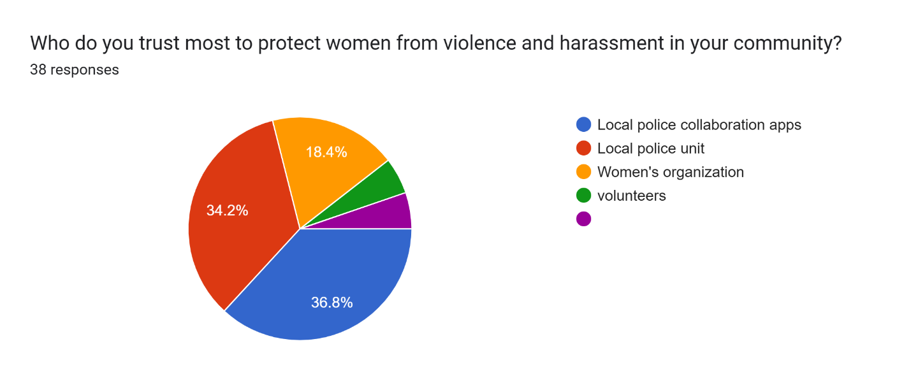
1. Critical Role in Ensuring Effective Collaboration
Survey Question:
Q1.Who plays the most critical role in ensuring effective collaboration between local law enforcement and the community for women’s safety?
Total Responses: 40
Results:
- Information and Communication Technology (ICT) – 35%
- Police leadership – 27.5%
- Women’s rights organizations – 22.5%
- Ordinary citizens – 12.5%
- Not important at all – 2.5%
Analysis:
- ICT is seen as the key enabler (35%) for effective collaboration, highlighting the importance of digital platforms, mobile apps, and real-time communication tools.
- Police leadership (27.5%) is also regarded as a strong factor, underlining the importance of proactive, accountable, and community-oriented law enforcement leaders.
- Women’s rights organizations (22.5%) play a supportive but slightly less central role in driving collaboration.
- Ordinary citizens received limited recognition (12.5%), possibly pointing to a lack of awareness or perceived capacity to effect change directly.
- The extremely low percentage for “Not important at all” suggests strong consensus on the importance of collaboration mechanisms.
2. Trust in Protecting Women from Violence and Harassment
Survey Question:
Q1.Who do you trust most to protect women from violence and harassment in your community?
Total Responses: 38
Results:
- Local police collaboration apps – 36.8%
- Local police unit – 34.2%
- Women’s organization – 18.4%
- Volunteers – 5.3%
- Others (assumed as very low or none) – minimal
Analysis:
- Most respondents (71%) trust formal law enforcement solutions (collaboration apps and police units) the most. This reflects growing confidence in technology-enabled policing and direct police intervention.
- Women's organizations, though respected, lag in trust. This may indicate the need for these organizations to build stronger community presence or better collaboration with law enforcement.
- Volunteers were the least trusted, possibly due to their limited authority or resources in handling serious safety issues.
Combined Insights:
- Technology as a Key Trust Builder: The community shows significant trust in digital solutions and ICT for both direct protection and collaboration. This points to the potential of expanding or investing in community safety apps and real-time reporting tools.
- Law Enforcement Must Lead Collaboration: Both police units and leadership are seen as foundational pillars for women’s safety. Any collaborative approach should focus on transparent, accountable, and responsive policing.
- Strengthening NGOs and Community Participation: While women’s rights organizations and volunteers are less trusted or seen as critical, their roles shouldn't be underestimated. Capacity building, visibility, and partnership with law enforcement could improve their impact.
- Policy Implication: A multi-stakeholder approach involving ICT systems, strong police leadership, and empowered organizations will be crucial to ensuring women's safety in Bangladesh. Initiatives should focus on trust-building, technology adoption, and inclusive dialogue with the community.
The proposed solution is to establish an Integrated Community Safety Network that enhances collaboration between local law enforcement, women’s organizations, and the community through improved digital tools and leadership training. This system would focus on expanding user-friendly police collaboration apps, strengthening police accountability, and integrating women’s organizations into digital response networks while increasing community awareness through outreach. This solution is validated by the survey findings, which show strong public trust in technology-based safety measures and law enforcement leadership. Most respondents identified police collaboration apps and ICT as the most trusted and critical elements, confirming the need for a technology-driven, cooperative approach to ensure women's safety in Bangladesh.
CONCLUSION: This research explores a critical social concern women’s safety in Bangladesh by evaluating how coordinated efforts between local law enforcement, community stakeholders, and digital technologies can foster a safer environment. The increasing incidence of harassment and violence in both public and private settings, supported by testimonies and national data, exposes persistent weaknesses in protection mechanisms, accountability, and community engagement. Despite progress through legal reforms and policy directives, these measures fall short without dynamic, real-time, and grassroots-level implementation. The study’s findings highlight a growing reliance on technology, particularly police-linked mobile applications and ICT-based reporting systems, signaling a move toward faster, more accessible, and citizen-focused safety solutions. Survey data reinforces the centrality of police leadership and community cooperation in enhancing protection efforts, underlining the importance of transparent, responsive, and gender-aware policing. Although women’s organizations and volunteers received less prominence in the results, their advocacy and outreach roles are essential and should be better integrated into law enforcement systems through collaborative digital networks. To address these challenges, the Integrated Community Safety Network (ICSN) is proposed as a forward-thinking solution aligned with the Sustainable Development Goals (SDGs), particularly those related to gender equity, reducing social disparities, and strengthening institutions. This model combines mobile technology, real-time GPS tracking, and cross-sector coordination to bridge existing gaps between victims, communities, and authorities. It further emphasizes the importance of long-term strategies, including digital literacy, community sensitization, and policy reform for sustainable impact. In conclusion, this research advocates for a transformation in the way women’s safety is approached shifting from passive responses to proactive, technology-supported, and community-driven strategies. By placing women lived experiences at the core and encouraging cooperative frameworks, the study offers meaningful contributions to policy development and community practice. Ensuring the safety of women must be recognized not just as a legal mandate, but as a shared civic duty requiring continuous innovation, trust-building, and collaborative action.
REFERENCES:
- Pandey, V. (2015). [Community Policing and Women Safety in India]. International Journal of Humanities & Social Science Studies (IJHSSS), 2(2), 229–239. Scholar Publications. http://www.ijhsss.com
- Ming, S., Mayfield, R. D. W., Cheng, H., Wang, K.-R., & Yunhuang. (2021). Examining interactions between community members and university safety organizations through community-sourced risk systems. Proceedings of the ACM on Human-Computer Interaction, 5(CSCW1), Article 37. https://dl.acm.org/doi/epdf/10.1145/3449111
- Shenoy, M. V., Gupta, A., Sridhar, S., Salaka, G., & Gupta, A. (2021). A holistic framework for crime prevention, response, and analysis with emphasis on women safety using technology and societal participation. IEEE Access, 9, 36656–36671. https://doi.org/10.1109/ACCESS.2021.3076016
- Talpur, M. S. H., Sarwar, R., Luhrani, A., Rajper, S., Talpur, F., Rehman, H., Chandio, J., Talpur, S. H., Chang, E. S., & Kalhoro, A. A. (2021). Smart sandal with IoT for women's safety and empowerment. International Journal of Advanced Trends in Computer Science and Engineering, 10(2),1305-1313.Available online: http://www.warse.org/IJATCSE/static/pdf/file/ijatcse1161022021.pdf
- AFP. (2025, March 5). Bangladeshi women alarmed by emboldened hardliners. DAWN https://www.dawn.com
- UNB. (2024, September 21). Attack on mountaineer Shayla: Case to be filed after attacker identified, family says. The Business Standard https://www.tbsnews.net
- (2020, March 7). Preventing discrimination and harassment of women at workplace. The Daily Star- https://www.thedailystar.net

